**Reading in the Junior School**

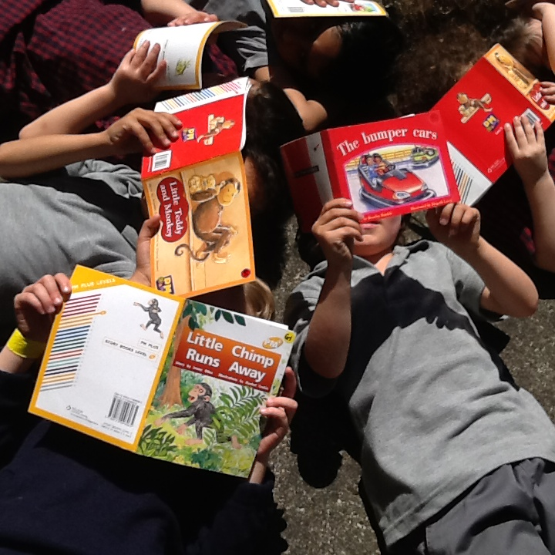

|  |  |
| --- | --- |
| 24 | Silver |
| 23 | Silver |
| 22 | Gold |
| 21 | Gold |
| 20 | Purple |
| 19 | Purple |
| 18 | Turquoise |
| 17 | Turquoise |
| 16 | Orange |
| 15 | Orange |
| 14 | Green |
| 13 | Green |
| 12 | Green |
| 11 | Blue |
| 10 | Blue |
| 9 | Blue |
| 8 | Yellow |
| 7 | Yellow |
| 6 | Yellow |
| 5 | Red |
| 4 | Red |
| 3 | Red |
| 2 | Magenta |
| 1 | Magenta |

Reading at home

The aim of this booklet is to explain reading at St Francis de Sales School, the reading levels, reading assessment and how you can help support your child with reading at home. Take ten to fifteen minutes a day to read with and to your child. Reading should be an enjoyable and rewarding experience for both of you.

Your child will bring a reading book home in his/her book bag Monday to Thursday. The book will be one that your child has already read in class with the teacher. As well as a book, there will be a word booklet with words to learn at the same reading level as the reading book.

Please keep reading books in the book bag; it keeps our books clean and safe. If book bags are not returned to school each day, then a new book cannot be sent home.

Books are have been read with the teacher are then put into book boxes for independent reading during class time.

Reading levels explained

New Zealand reading books are levelled according to colour and number. Books start at Magenta, Level 1 and go up to Silver, Level 24. To make it easier the reading levels have been organised into three groups; Emergent, Early and Fluency.

**Emergent**

Levels 1 & 2 (magenta)

**Early**

Levels 3 - 14 (red to green)

**Fluency**

Levels 15 + (orange to silver)

Most reading books have a colour wheel or chart on the back cover to indicate the book level. To make it easier, some books are the same colour as the reading level of the book.

National Standard Expectations

|  |  |
| --- | --- |
| 24 | Silver |
| 23 | Silver |
| 22 | Gold |
| 21 | Gold |
| 20 | Purple |
| 19 | Purple |
| 18 | Turquoise |
| 17 | Turquoise |
| 16 | Orange |
| 15 | Orange |
| 14 | Green |
| 13 | Green |
| 12 | Green |
| 11 | Blue |
| 10 | Blue |
| 9 | Blue |
| 8 | Yellow |
| 7 | Yellow |
| 6 | Yellow |
| 5 | Red |
| 4 | Red |
| 3 | Red |
| 2 | Magenta |
| 1 | Magenta |

National Standard Expectation for children who have attend school for 3 years (8 year olds).

National Standard Expectation for children who have attend school for 2 years (7 year olds).

National Standard Expectation for children who have attend school for 1 years (6 year olds).

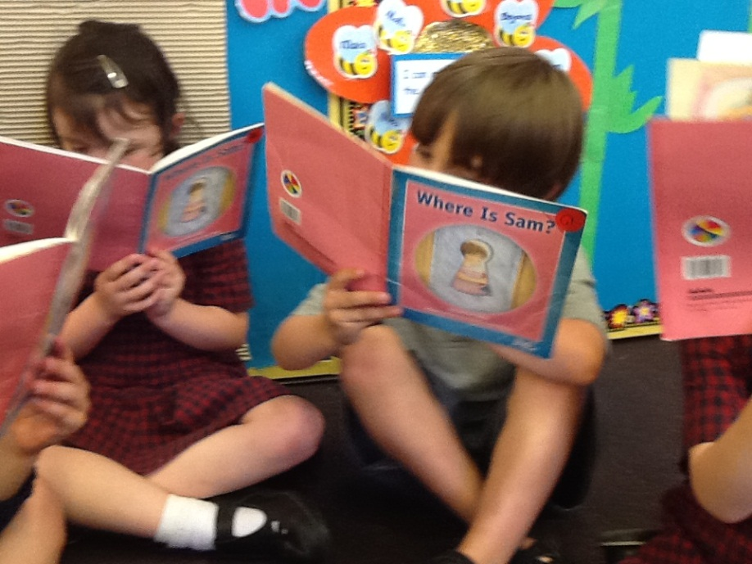

Emergent Reading Stage Levels 1 & 2

Memory for Text

In the early stages of reading, it is usual for children to memorise texts. This is an important stage of reading. Children are learning about books and language structures.

Pictures

Please do not cover up pictures. Pictures are very important in the early reading levels. They give the story meaning and assist with problem solving tricky words.

Early Reading Behaviours

Children need to know where to start and in which direction to read. Pointing to the words in the early stages is also important and helps establish early reading behaviours.

Once your child has developed a reading vocabulary of 10-20 words (referred to as high frequency words), he/she is ready for Level 3 reading books (red).

[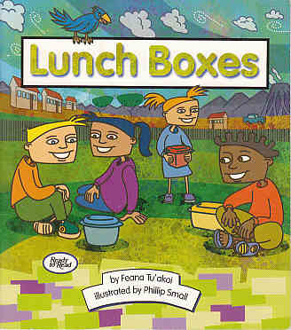](http://reading.rjh.school.nz/SchoolJournal-ReadytoRead-CDTracks/Readalong-2001/04%20Lunch%20Boxes.mp3)

[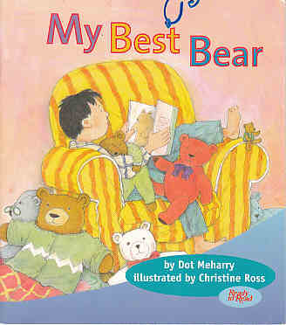](http://reading.rjh.school.nz/SchoolJournal-ReadytoRead-CDTracks/Readalong-2001/05%20My%20Best%20Bear.mp3)[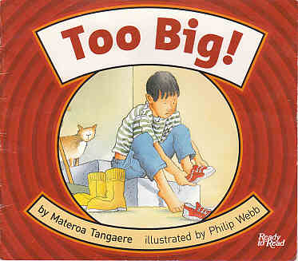](http://reading.rjh.school.nz/SchoolJournal-ReadytoRead-CDTracks/Readalong-2000/02%20Too%20big%20by%20Materoa%20Tangaere.mp3)[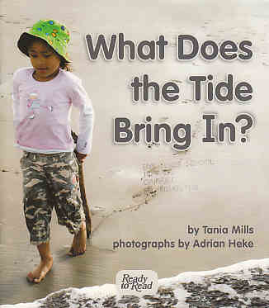](http://reading.rjh.school.nz/SchoolJournal-ReadytoRead-CDTracks/Readalong-2008/01%20What%20Does%20the%20Tide%20Bring%20In-.mp3)

Early Reading Stage Levels 3 – 14

Reading Behaviours

Once your child is at yellow level they no longer need to point to the words. Encourage your child to read with his eyes, not his/her finger.

Being able to retell a story and to answer questions about the story are very important at this stage. Some children become very good at decoding words but do not understand what they are reading. Discussing the book when you are reading with your child is an excellent way to foster understanding and comprehension. Remember to keep reading fun.

Fluency Reading Stage Levels 15-25

Fluency

Good readers read quickly. They use expression and correct phrasing. Reading sounds like talking. Reading books with direct speech or plays are excellent ways to make reading sound interesting.

Comprehension

Reading shifts focus once children are at the fluency stage of reading. They are no longer learning to read but reading to get information from books.

[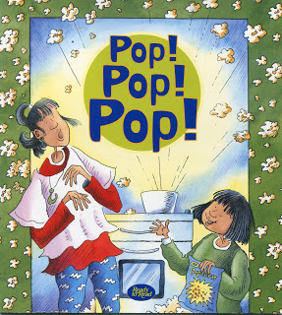](http://4.bp.blogspot.com/-FA2-ztZBbiw/Ui0teYm-JtI/AAAAAAAAAC4/GIpLjq5Y98g/s1600/popcorn.jpg)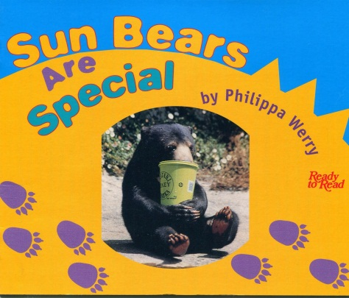

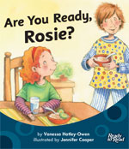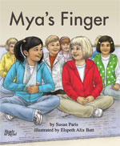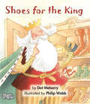

Reading with your child at home

Setting the atmosphere

* Help your child find a quiet, comfortable place to read.
* Have your child see you as a reading model.
* Read aloud to your child.
* Discuss the stories you have read together.
* Recognise the value of silent reading.
* Keep reading time enjoyable and relaxed.

Responding to errors in reading

To produce independent readers who monitor and correct themselves as they read, the following prompts are recommended.

Give your child wait time of 5 to 10 seconds. See what he/she attempts to do to help himself/herself.

Say

* “Look at the picture.” (Yes you can do that – **do not cover pictures**.)
* “Run your finger under the word and say it slowly.”
* “Go back to the beginning and get your mouth ready for the first sound.” (letter/blend/digraph)
* “Does your word make sense?”
* “Does your word look right?”
* “Does your word sound right?”
* Tell your child the word.

Most important, focus on what your child is doing well and attempting to do. Remain loving and supportive. When your child is having difficulty and trying to work out the tricky words, comments such as the following are suggested:

* “Good for you. I like the way you tried to work that out.”
* “That was a good try. Yes that word would make sense there.”
* “I liked the way you looked at the picture to help yourself.”
* I liked the way you went back to the beginning of the sentence and tried that again. That’s what good readers do.”

Monitoring Reading – Running Record

Your child’s teacher will monitor his/her progress very closely. Running records, the recording of children’s behaviour when reading, are an accurate and excellent assessment tool to monitor reading progress.

Observation Survey

After 1 year at school and on or about your child’s 6th birthday, a trained Reading Recovery teacher will assess your child’s progress against the National Standards using a test called an Observation Survey.

The Observation Survey is a series of 7 tasks designed by Marie Clay to measure children’s progress in reading and writing near their sixth birthday.

At St Francis de Sales School, the Observation Survey is administered by a trained Reading Recovery teacher. The child’s behaviours are recorded during each task and the results are analysed. The 7 tasks are:

1. Alphabet Knowledge
2. Concepts About Print
3. Clay Word Test
4. BURT Word Test
5. Writing Vocabulary
6. Hearing and Recording Sounds in Words
7. Running Record

The results of the Observation Survey are summarised and given to the class teacher to inform next learning steps.

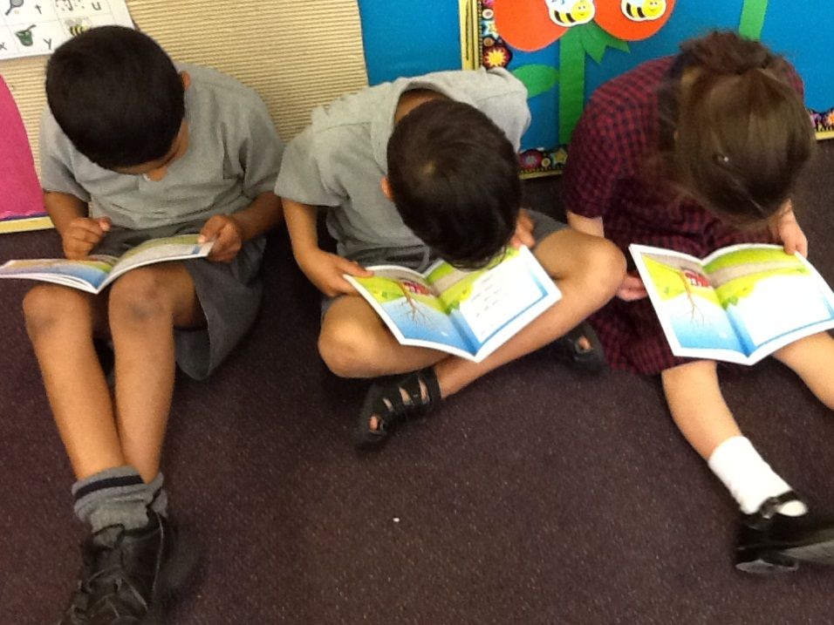

**Reading Strategy**

**If I get stuck on a word I need to go back and re-read.**

|  |  |  |  |  |  |
| --- | --- | --- | --- | --- | --- |
| ❶ | ❷ | ❸ | ❹ | | |
|  |  |  | **Does it:** | | |
|  |  |  |
| Go back and  re-read the sentence.  Make a prediction. | Look for bits I know.  Do I recognise any sounds in the word? | Point under the word.  Read across it, putting all the sounds together to sound like a word you know. | Look right? | Sound right? | Make sense? |